Plasma Edge Theory in Fusion Devices

A. First^{1∗} , B. Second¹ , C. Third² , and D. Fourth³

¹ Japan Atomic Energy Agency, Rokkasho, Aomori 039-3212 Japan
² Graduate School of Engineering, Kyoto University, Katsura, Kyoto 615-8540, Japan
³ Graduate School of Engineering, Osaka University, Suita 565-0871 Japan

Received XXXX, revised XXXX, accepted XXXX
Published online XXXX

Key words Edge plasma, turbulent transport, fluid simulation.

The invited and contributed papers will be included in the proceedings of the workshop and published in the journal “Contributions to Plasma Physics”. The papers will go through the usual refereeing process. The page limit should strictly be kept; 6 pages for a contributed paper and 8 pages for an invited paper. The author is requested to submit an electronic manuscript as a PDF; through PET15 WEB homepage http://bpsi.nucleng.kyoto-u.ac.jp/pet15/ or by e-mail to PET15@p-grp.nucleng.kyoto-u.ac.jp or at the workshop registration desk. 3 hard copies of the manuscript are also brought to the workshop registration desk.
Copyright line will be provided by the publisher

1 Introduction

The invited and contributed papers will be included in the proceedings of the workshop and published in the journal “Contributions to Plasma Physics”. The papers will go through the usual refereeing process. The page limit should strictly be kept; 6 pages for a contributed paper and 8 pages for an invited paper.

Paper size: A4. Margin: top 25 mm, bottom 30 mm, left 25 mm and right 25 mm
Line-spacing: 12pt for the text (10pt font)
Font: Times New Roman and Symbol
Size: Title = 14 pt. bold, Author = 10 pt. bold, Affiliation = 9 pt., Abstract 9 pt., Footnote 8 pt.,
Text = 10 pt., Section title = 12 pt. bold, Sub-section title = 10 pt., Acknowledgment = 9 pt.,
Reference = 9 pt., Figure caption = 9 pt.

It is recommended that the paper is prepared by using LaTeX cpp-style sheets from
http://www.wiley-vch.de/vch/journals/2222/public/cpp.zip

The author is requested to submit an electronic manuscript as a PDF;
through PET15 WEB homepage http://bpsi.nucleng.kyoto-u.ac.jp/pet15/ (click ‘MANUSCRIPT submission’ icon in the side menu)
or by e-mail to PET15@p-grp.nucleng.kyoto-u.ac.jp or at the workshop registration desk.

Deadline for the submission of manuscript is 9 September 2015. 3 hard copies of the manuscript are also brought to the workshop registration desk.

2 Model Equation

The 4-field reduced MHD model consists of vorticity equation, Ohm’s law, parallel momentum equation, and density evolution equation [1, 2]. The poloidal Alfv´en time and the plasma minor radius are used for the normalization. In the circular tokamak geometry (r, θ, ζ), these are given by

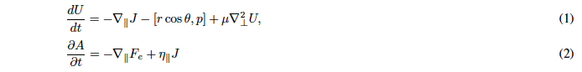
----------------------
∗ Corresponding author. E-mail: xx.yyy@xxx.yyy.zz, Phone: +81 12 333 4445, Fax: +81 12 333 4446

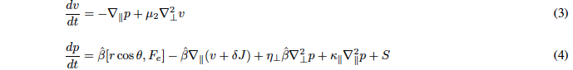

where d/dt = ∂/∂t + [φ, ], ∇|| = ∇||⁽⁰⁾ − [A, ], [f, g] = (∂f/∂r)(∂g/r∂θ) − (∂f/r∂θ)(∂g/∂r), ∇²⊥ =(∂/r∂r)(r∂/∂r) + ∂²/r²∂θ², U = ∇²⊥F_{i}, F_{i} = φ + δ_{i}p, F_{e} = φ −δ_{e}p, J = ∇²⊥A, τ = T_{e}/T_{i}, δ = c/(aω_{pi}), δ_{i} = δ/(1 + τ ) , δ_{e} = δτ/(1+τ) , βˆ = β/(1 + β) .

3 Simulation Result

3.1 Nonlocal Transport by Convection

In this simulation, the cylindrical source is applied at t = 960 after saturation of the resistive ballooning turbulence, which is excited in the peripheral region. In this phase, the flux-averaged density profile is gradually increasing due to the particle source. Then, the source is switched off at t = 1200. Figure 1 shows the time evolution of internal energy for each Fourier mode.

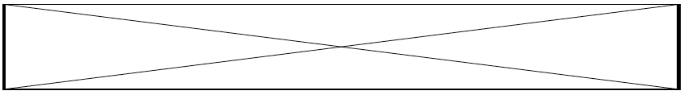
Fig. 1 Time evolution of internal energy for each Fourier mode. (0, 0) and (±1, 0) modes are dominant.

3.2 Interaction between (0, 0) and (±1, 0) modes

In this subsection, the detail analysis is carried out based on the energy balance equations for p(r, 0, 0) and p(r, ±1, 0). Figure 2 and 3 show the radial profile of each term in RHS of Eqs. (8) and (9) at t = 1350 . It is shown that the convective nonlinearity (RHS1) in Eq.(8) is dominant (Fig. 2), which contributes the nonlocal transport, via three wave coupling (1, 0) + (−1, 0) → (0, 0) . On the other hand, the toroidal coupling (RHS2) in Eq. (9) mainly drives (±1, 0) modes (Fig. 3).

Fig. 2 Radial profile of each term in RHS of Eq. (8) at t = 1350. RHS1 indicates convective nonlinearity, RHS2, toroidal coupling, RHS5, dissipation, respectively. | Fig. 3 Radial profile of each term in RHS of Eq.(9) at t = 1350.

4 Summary

The nonlinear simulation is performed using the 4-field RMHD model with particle source to investigate the nonlocal transport phenomena. It is found that the nonlocal transport appears in the vicinity of q = 3/2 surface after switching-off the source as a transient plasma response. In this simulation, p(r, ±1, 0) modes play an important role in the nonlocal transport.
As future works, (1) the q-dependence (the role of rational surface), (2) the source shape such as 3D spherical source, (3) the cold pulse propagation taking electron temperature fluctuation into account should be investigated to identify the nonlocal transport.

Acknowledgements An acknowledgement may be placed at the end of the article. This work is partially supported by Grant-in-Aid for Scientific Research of Japan Society for the Promotion of Science.

References

[1] R.D. Hazeltine and J.D. Meiss, Phys. Rep. 21, 1 (1985).
[2] M. Yagi, S. Yoshida, S.-I. Itoh et al., Nucl. Fusion 45, 900 (2005).
[3] L. Laurent, Plasma Phys. Control. Fusion 28, 85 (1986).
[4] E.D. Fredrickson, K. McGuire, A. Cavallo et al., Phys. Rev. Lett. 65, 2869 (1990).
[5] R.W. Hockney and J.W. Eastwood, Computer Simulation Using Particles (McGraw-Hill, New York, 1981).
[6] M. Yagi, K. Shimizu, T. Takizuka, M. Honda, N. Hayashi, K. Hoshino, and A. Fukuyama, Contrib. Plasma Phys. 52, 372
(2012).
[7] J.D. Callen and M.W. Kissick, Plasma Phys. Control. Fusion 39, B173 (1997).
[8] A. Loarte et al., 24th IAEA Fusion Energy Conf., San Diego, USA (2012) ITR/1-2.

